2D Desktop

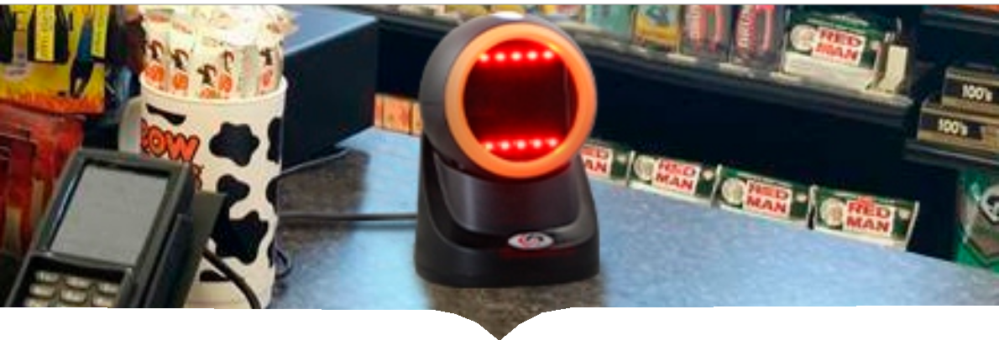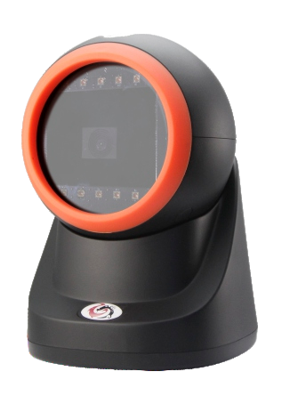

**Barcode Scanner**

**XL-2302**

◎ The best cost-performance desktop scanning solution

◎ Compatible with Linux, Android, Windows XP7/8/10/MAC OS

◎ Plug and play. No need to install the driver. Support POS systems, cash registers

◎ With larger angles, adjustable omni-directional scanning head meets various needs

◎ High speed and reliable performance on all common 1D and 2D codes

|  |  |  |  |
| --- | --- | --- | --- |
| Model | XL-2302 | Cable | Straight 2.0m |
| Light Source | Red LED (lighting) color temperature 5600K LED | Connector Type | RJ-45 Phone jack connector |
| CPU | 32bit MIPS @1G Hz | Program Upgrade | Online |
| Scan Mode | Continue scanning & Automatic induction | Input Voltage | DC 5Volts |
| Image Size | 1280x800 pixel | Working current | 130mA |
| Scanning speed | 60 fps/s | stand-by current | 100mA |
| Decoding Depth | 0-200mm@(13mil UPC/EAN 100%, PCS=90%) | Drop Durability | Designed to withstand 1.5M drop |
| Mnimum Resolution | 4mil | Interface | USB-HID, RS-232, USB-VCP |
| Indicator | （Buzzer), LED（Blue/Red) | Temperature (Operating) | 0°C-50°C |
| Size | L × W × H:150 x 100 x 110mm | Temperature (Storage) | -40°C-70°C |
| Weight | 348g (without cable) | Humidity | 5% to 95% (non-condensing) |
| Case Material | ABS + PC | Light Levels | Daylight, 0-100,00 Lux Fluorescence, 0-5,000 Lux |
| Decoding Capability | 1D: UPC，EAN，Code 39 (with full ASCII)，Codabar，Code 128，Code 93，Code 11，Interleaved 2 of 5，Industrial 2 of 5; Matrix 2 of 5，MSI Plessy，GS1 DataBar，etc  2D: PDF417，Data Matrix，QR Code | | |